Week 4 Lab: Database Encryption
Transparent Data Encryption (TDE) protects data at rest by encrypting database files at the storage layer, including data files, log files, and backups, without requiring application-level changes (Microsoft, 2024). Its primary use cases include regulatory compliance: HIPAA, PCI-DSS, and SOX each require demonstrable controls over sensitive data stored on disk, and protection against physical media theft, since TDE-encrypted backups cannot be restored without the originating certificate and master key (Microsoft, 2024; Bertino & Sandhu, 2005).
To remove TDE, the process must be reversed in sequence. First, run ALTER DATABASE AdventureWorks2025 SET ENCRYPTION OFF and wait for the decryption scan to complete, confirmed via sys.dm_database_encryption_keys showing encryption_state = 1. Then drop the Database Encryption Key inside the target database, drop the server certificate, and finally drop the master key from the master database if it is no longer needed (Microsoft, 2024).
The most important thing I wish I had known is that TDE follows a strict three-layer hierarchy which includes master key, certificate, Database Encryption Key, and each layer must exist before the next can be created (Microsoft, 2024). Working on a shared Horizon VM meant the master key and encryption settings from a prior session were already in place, causing both the CREATE MASTER KEY and SET ENCRYPTION ON commands to return errors. Running the Step 1 verification query first would have immediately revealed the existing state and prevented both errors. The lab also reinforced that errors are not always failures because both messages accurately described the environment rather than indicating anything broken.

Figure 1: Checking for existing master keys – 0 rows returned, confirming no prior master key exists
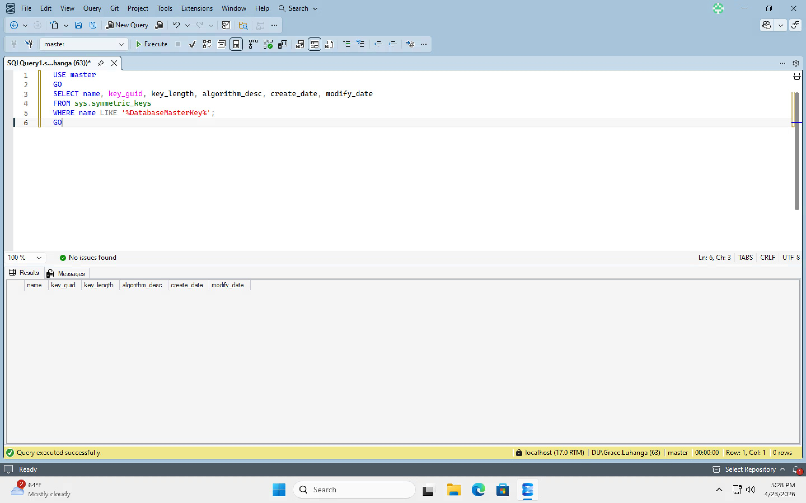

Figure 2: Master key verified – ##MS_DatabaseMasterKey## present, AES_256, 256-bit key length
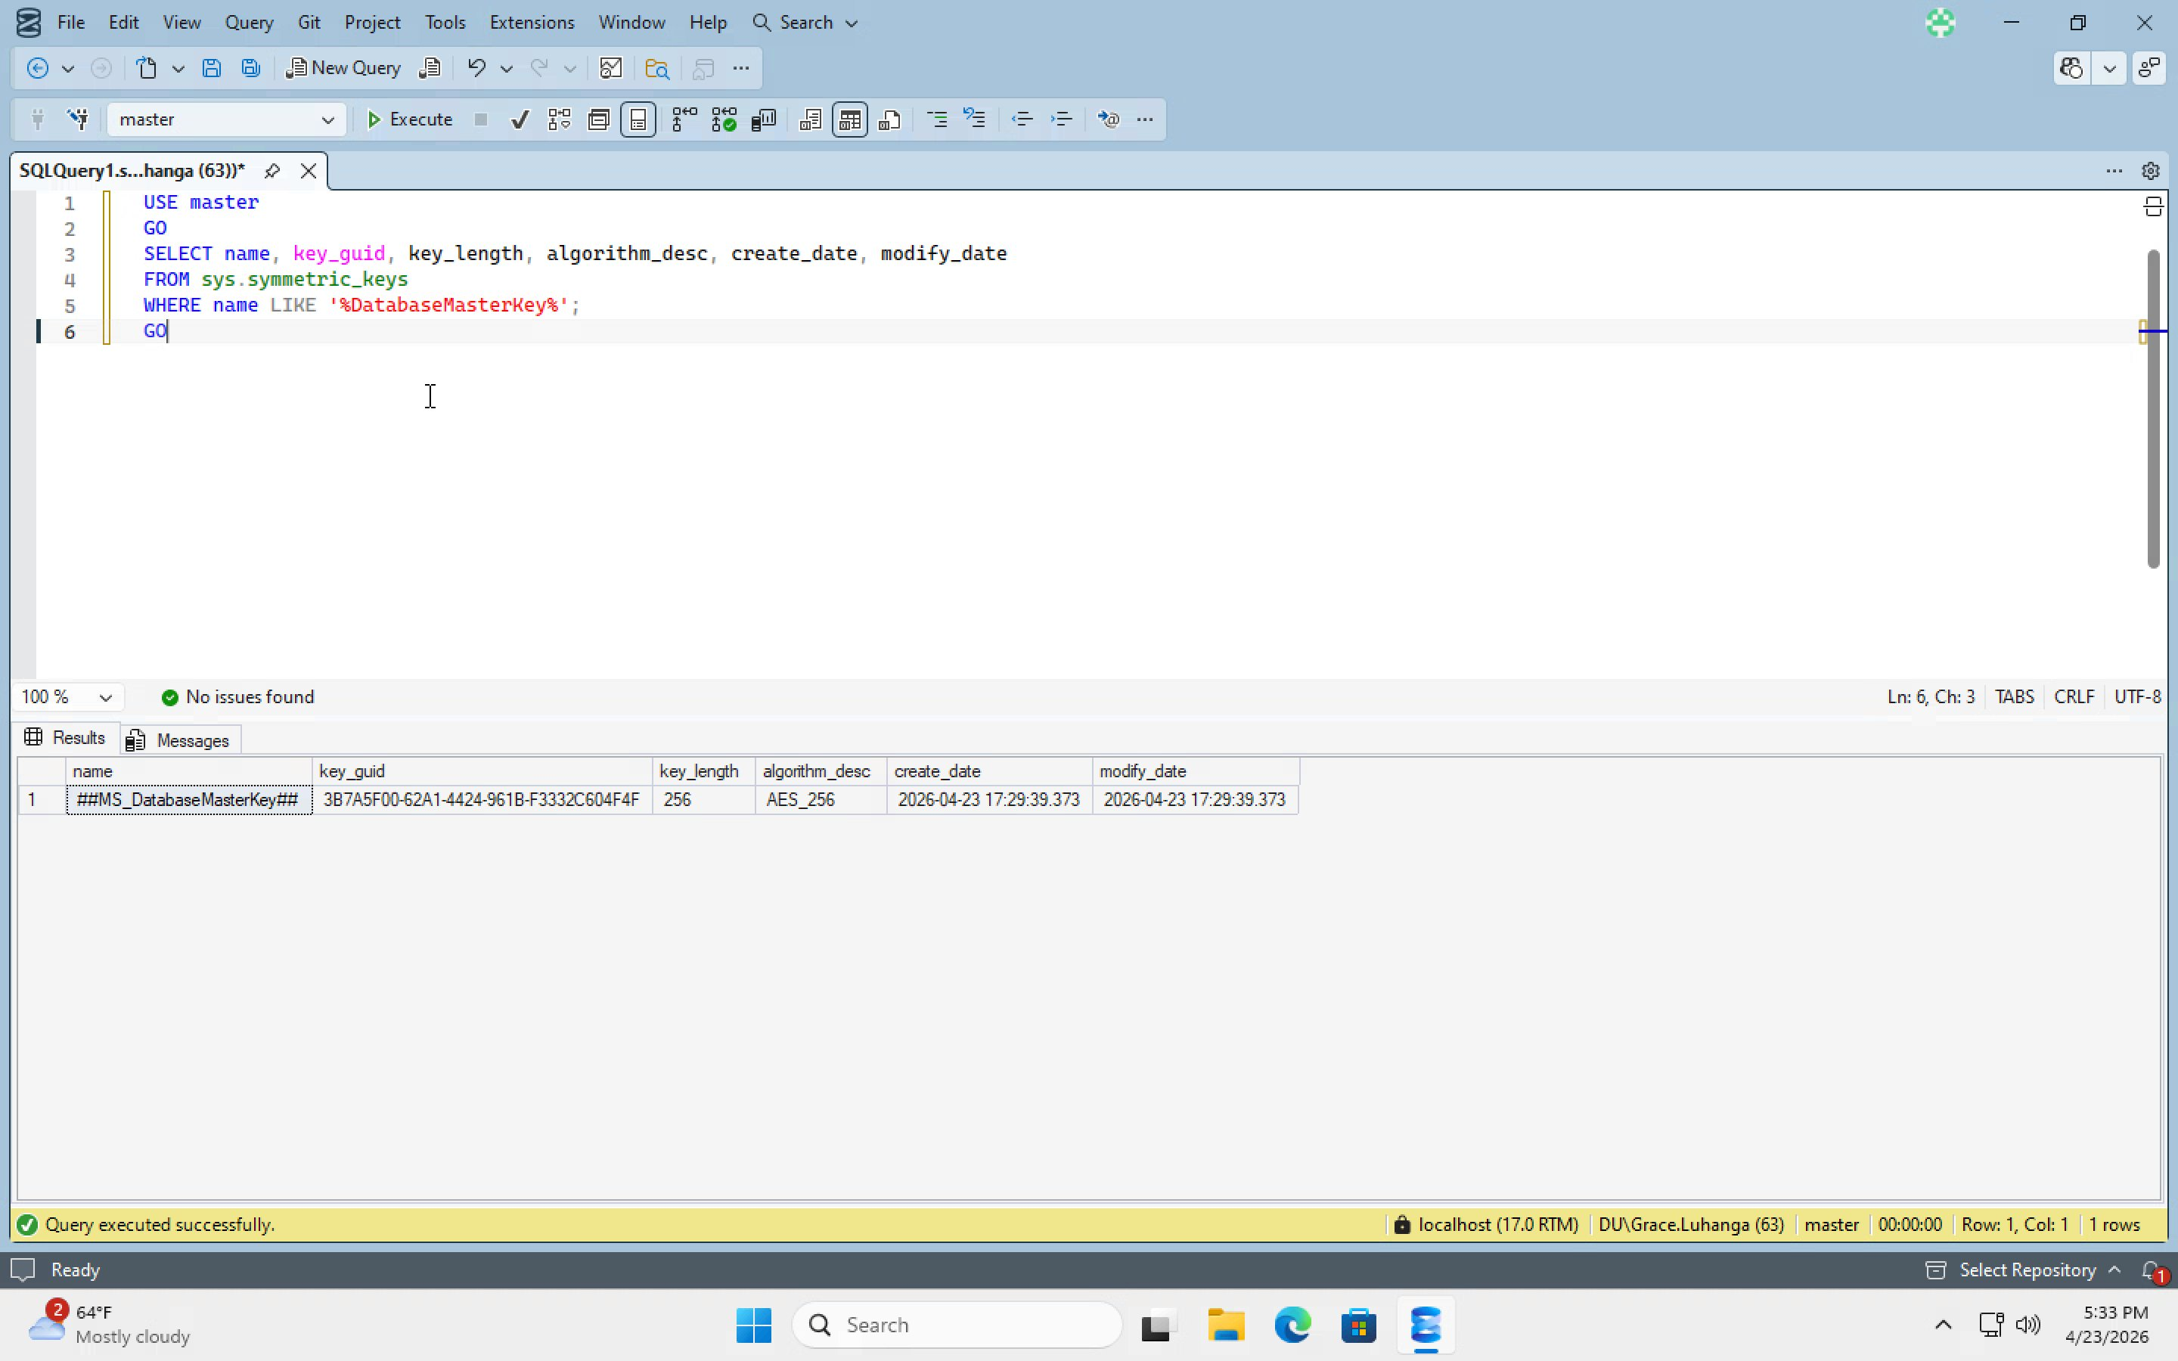

Figure 3: Certificate MyServerCert created and protected by the master key
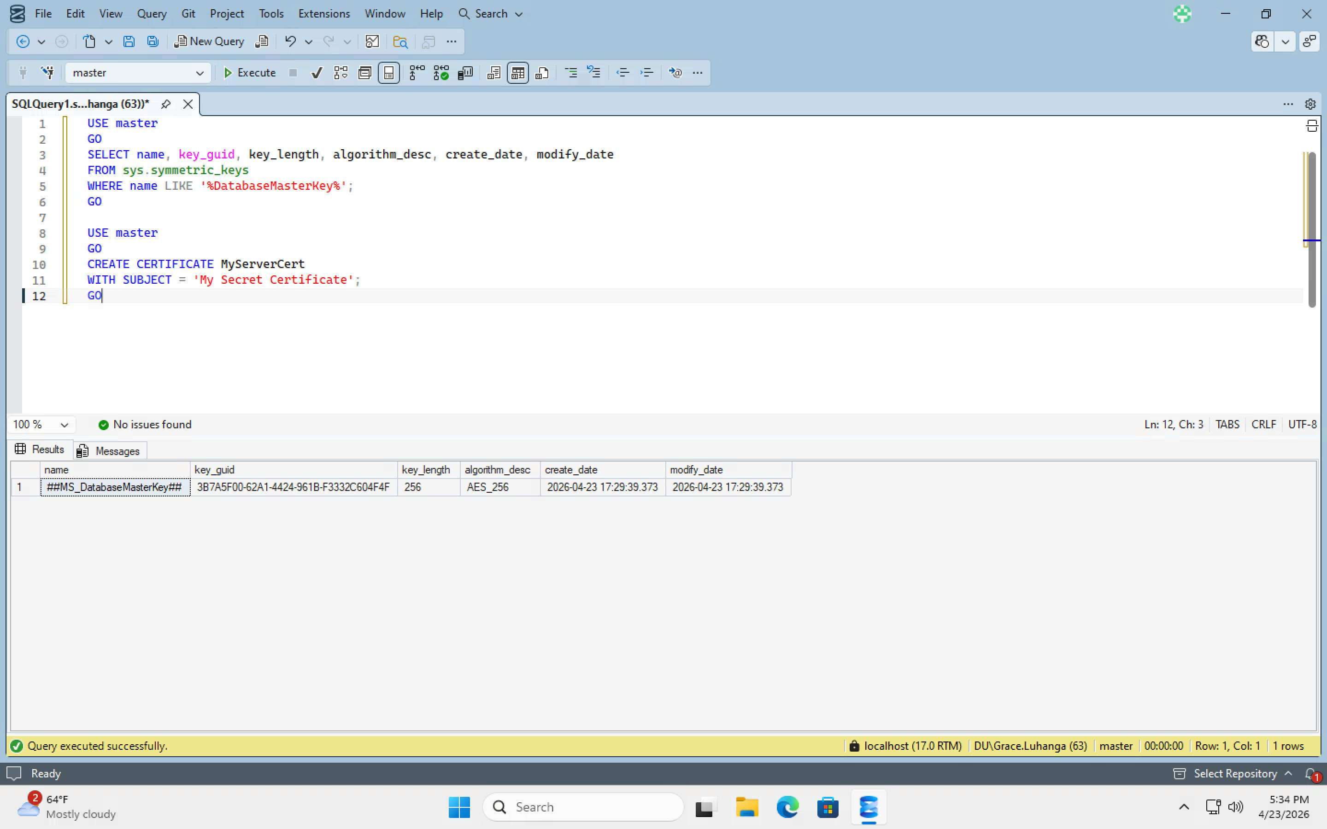

Figure 4: sys.certificates query results – MyServerCert visible as ENCRYPTED_BY_MASTER_KEY alongside system certificates
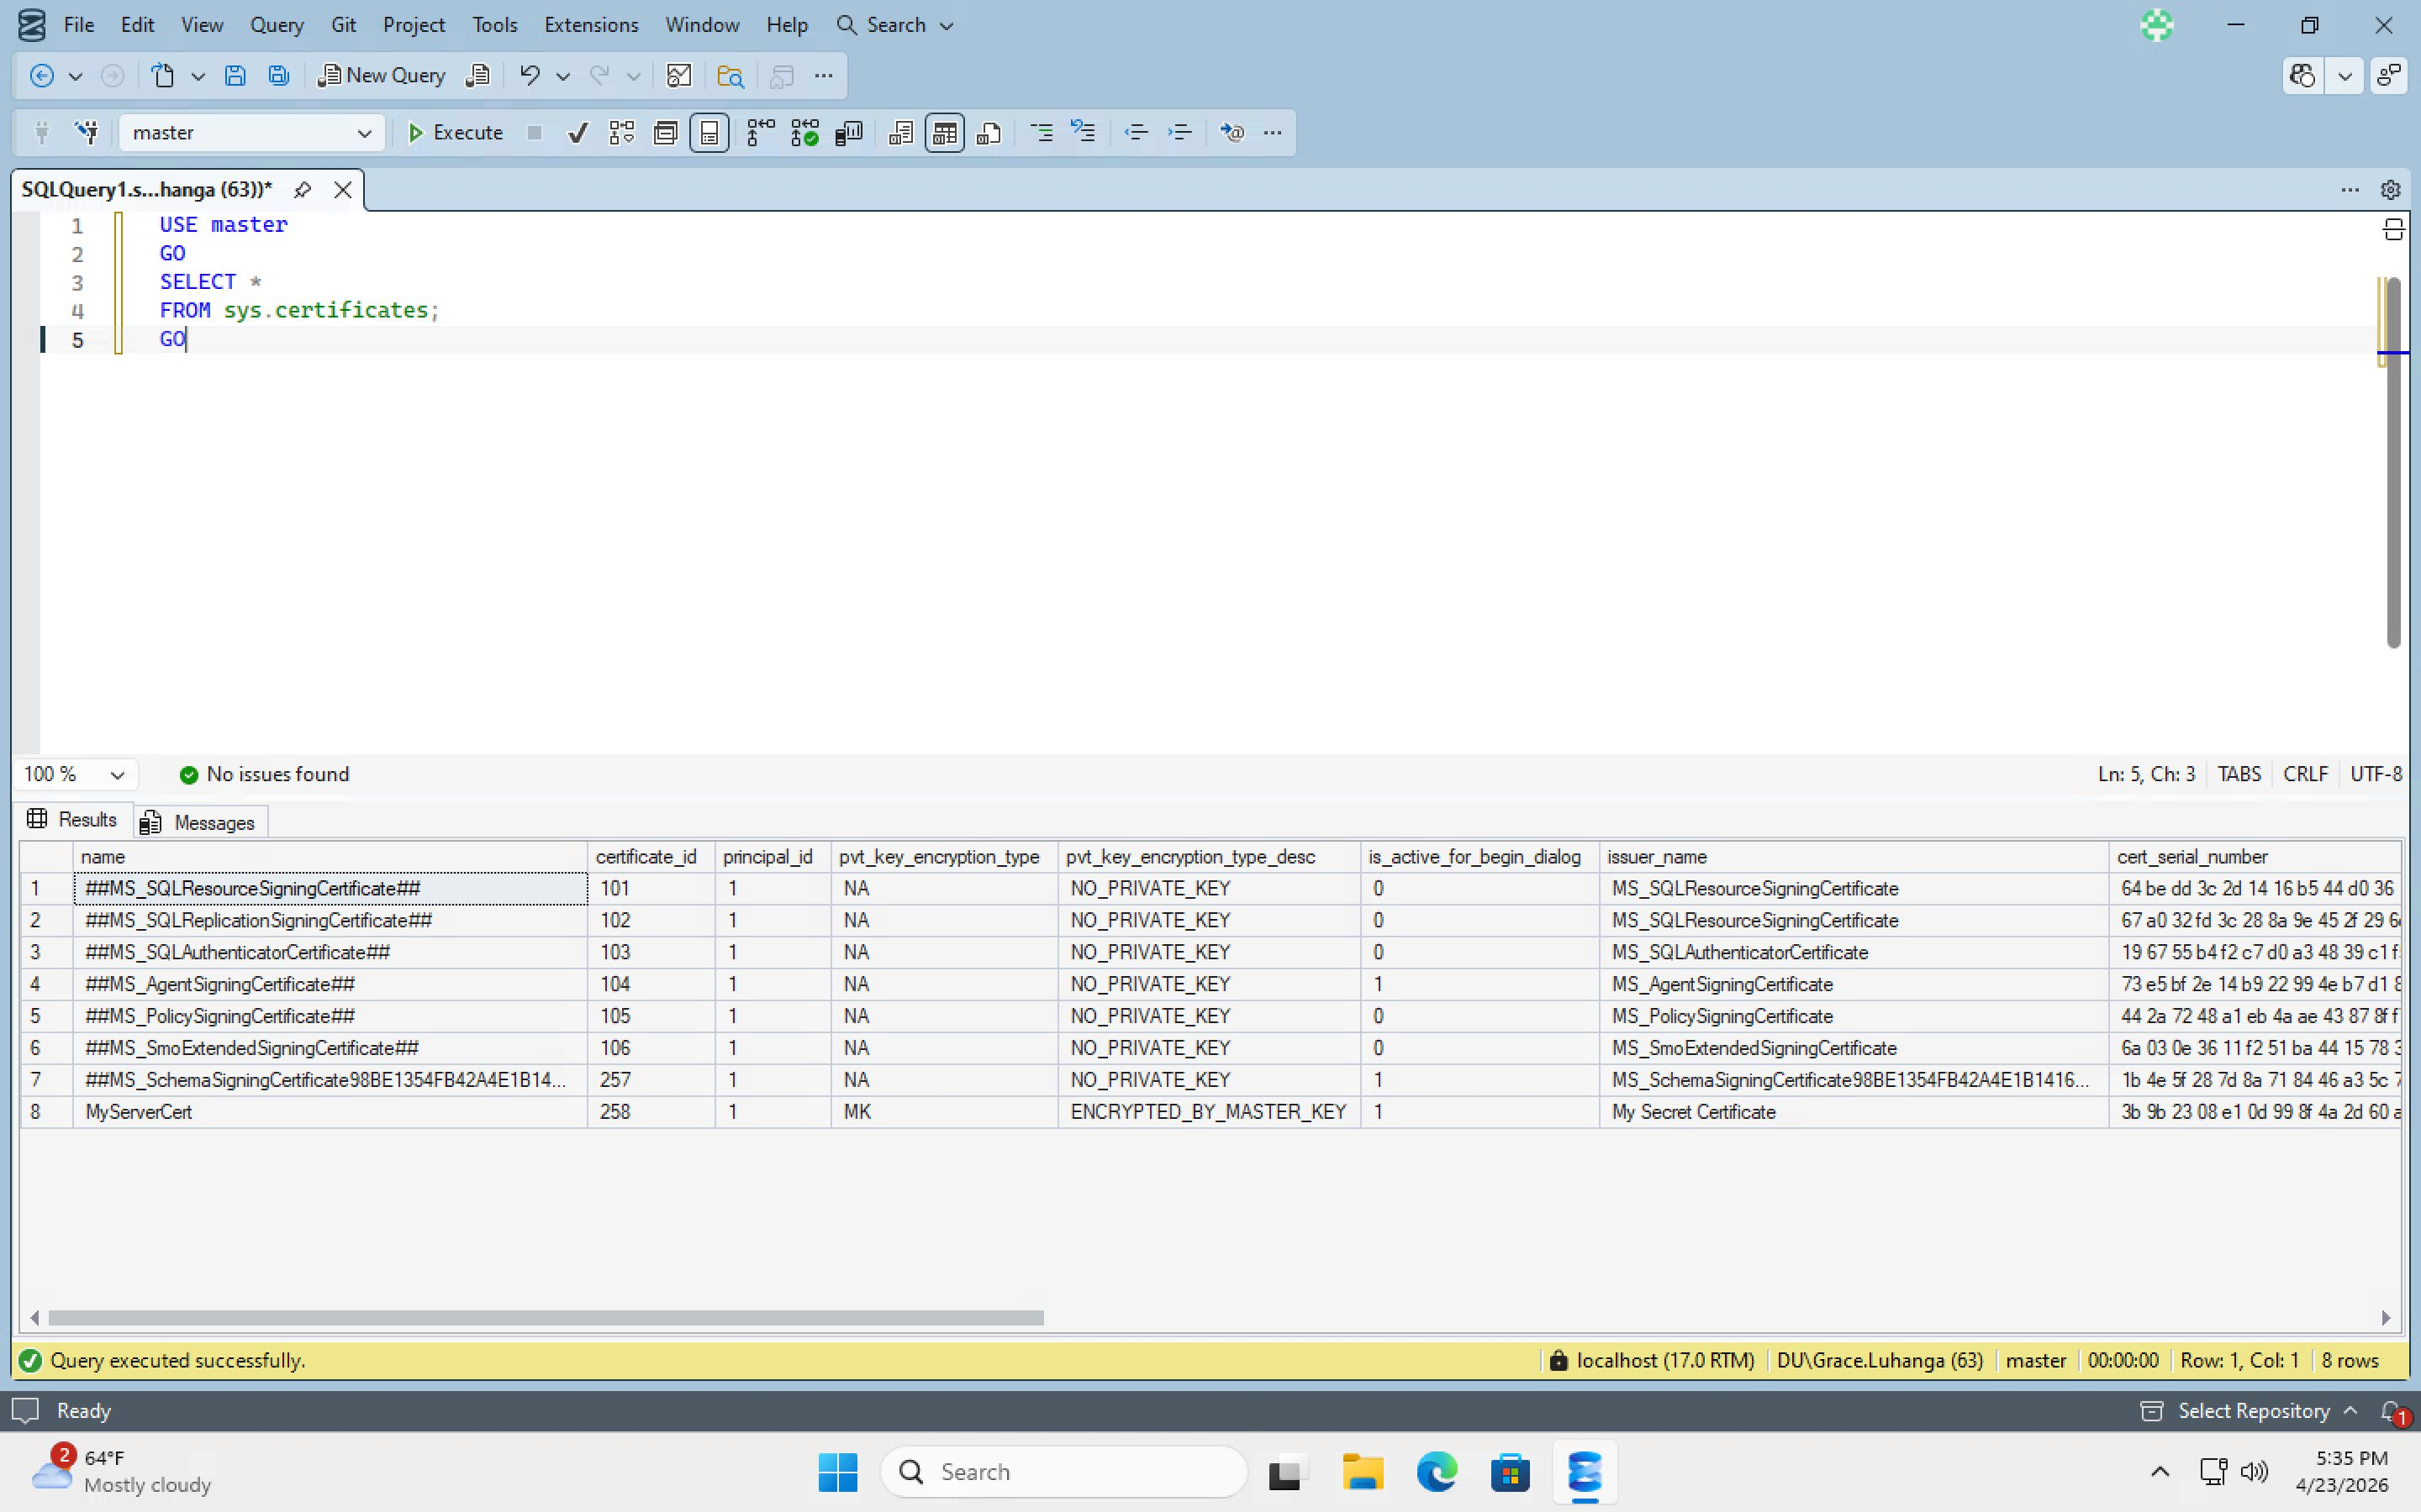

Figure 5: Database Encryption Key created for AdventureWorks2025 using AES_256 encrypted by MyServerCert
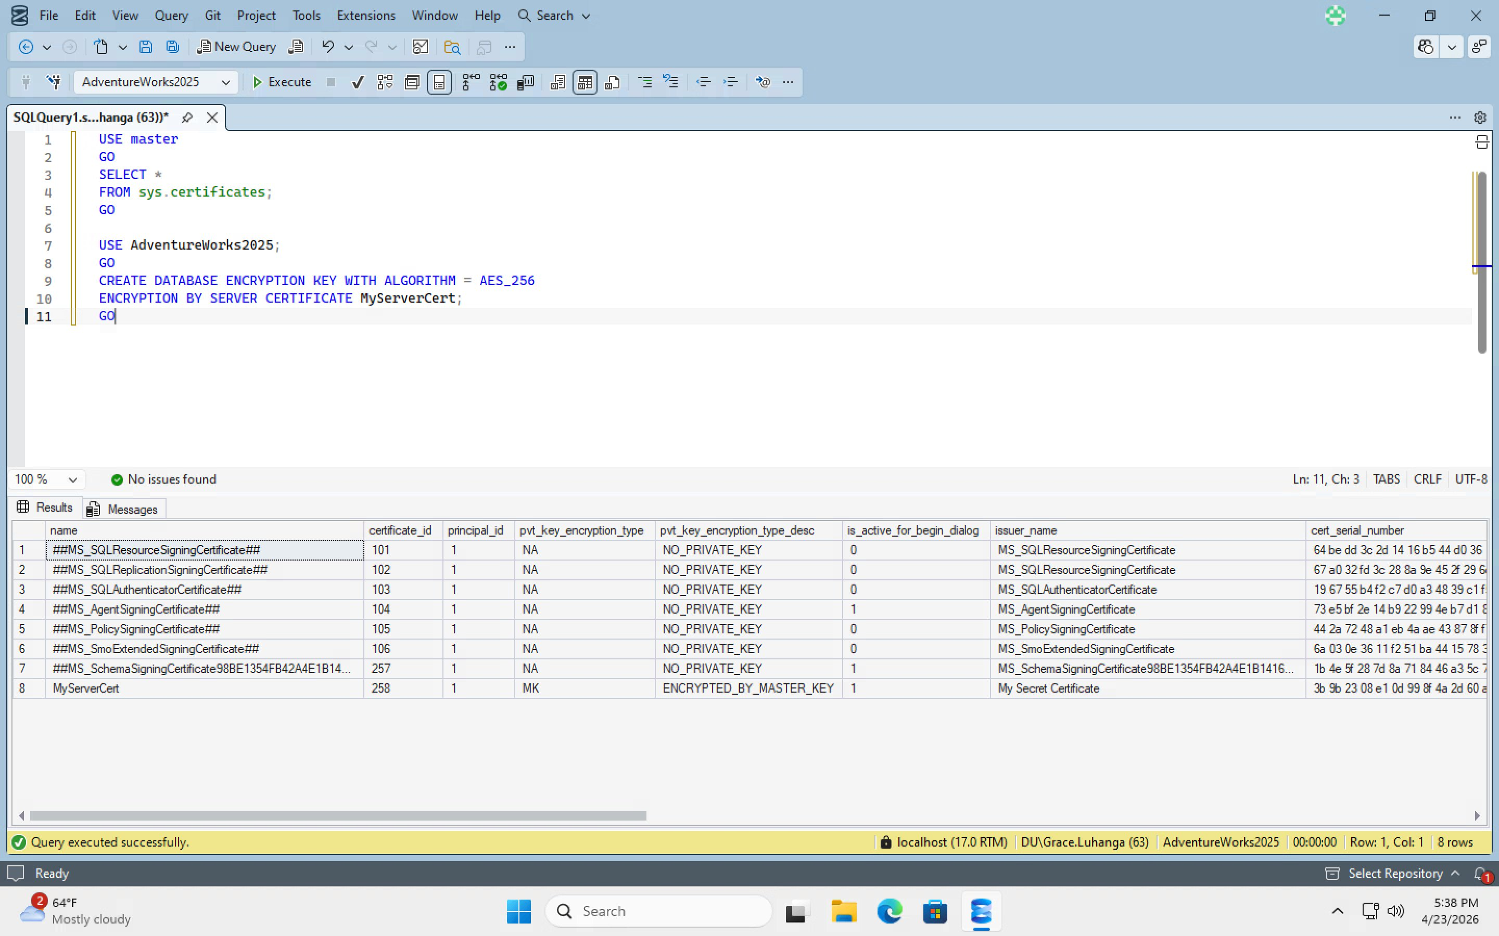

Figure 6: sys.dm_database_encryption_keys results – database_id 5, encryption_state 1, AES 256-bit, CERTIFICATE_OAE encryptor type
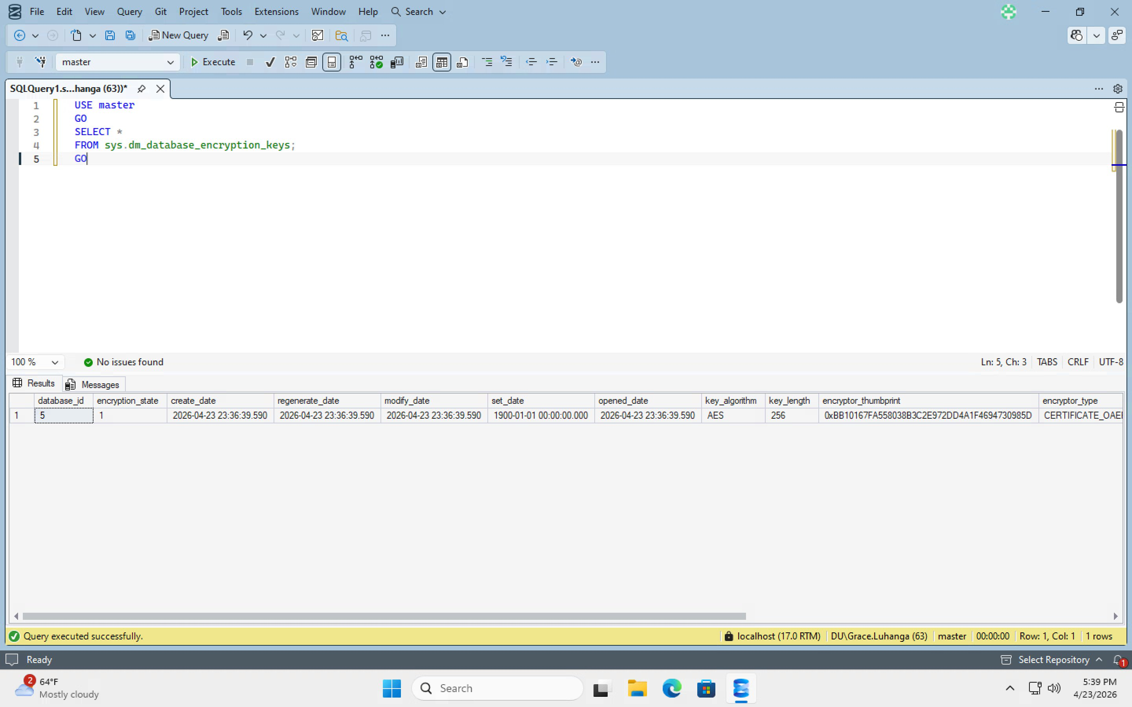

Figure 7: SET ENCRYPTION ON – error confirms encryption was already enabled on the shared Horizon VM from a prior session
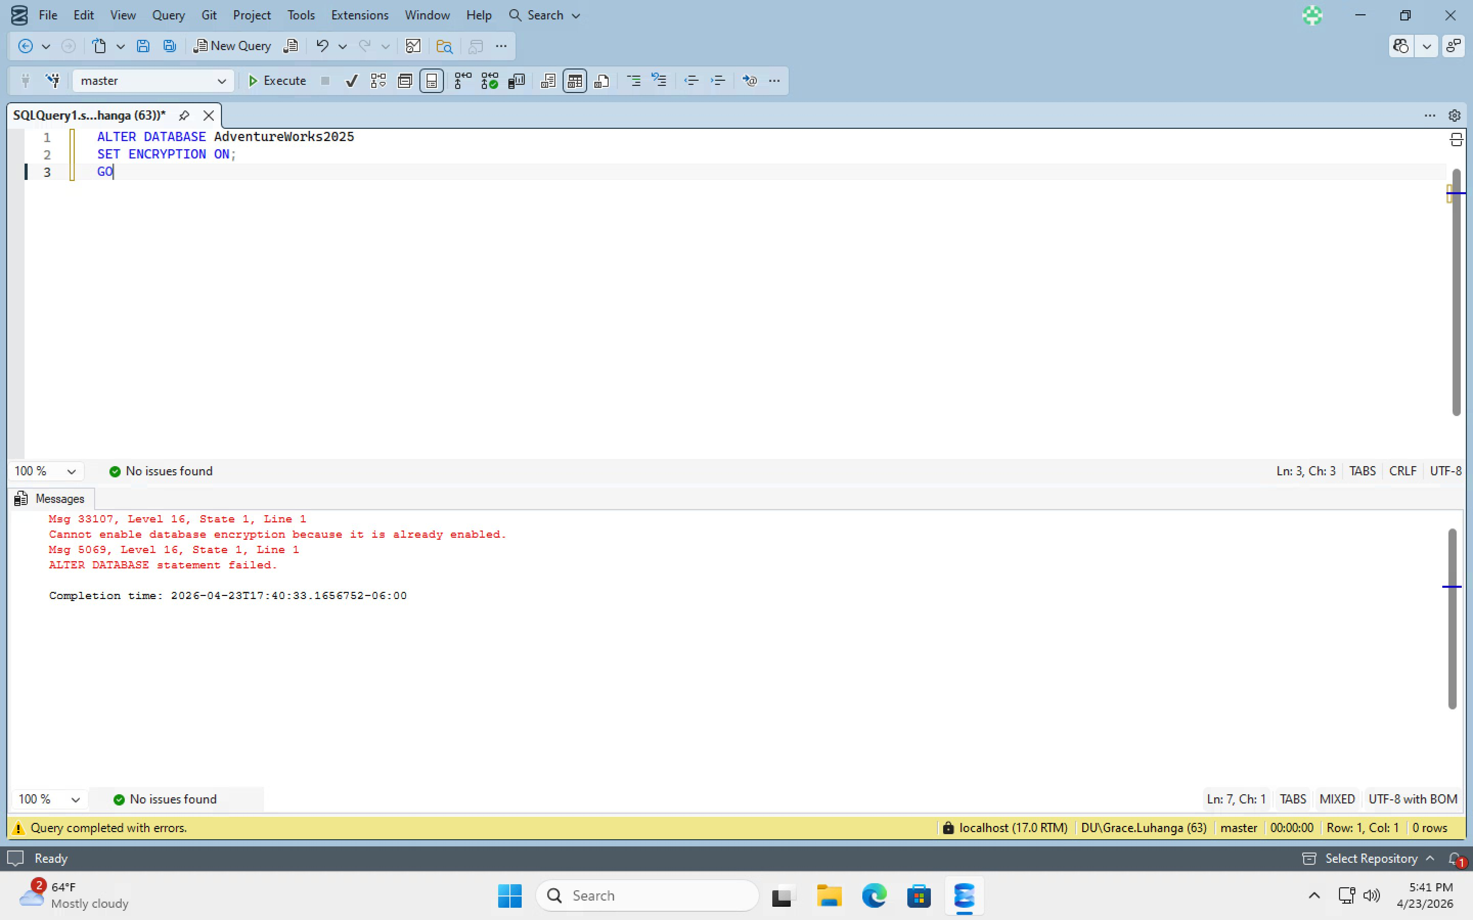

Figure 8: Database Properties – Options page showing Encryption Enabled = True for AdventureWorks2025
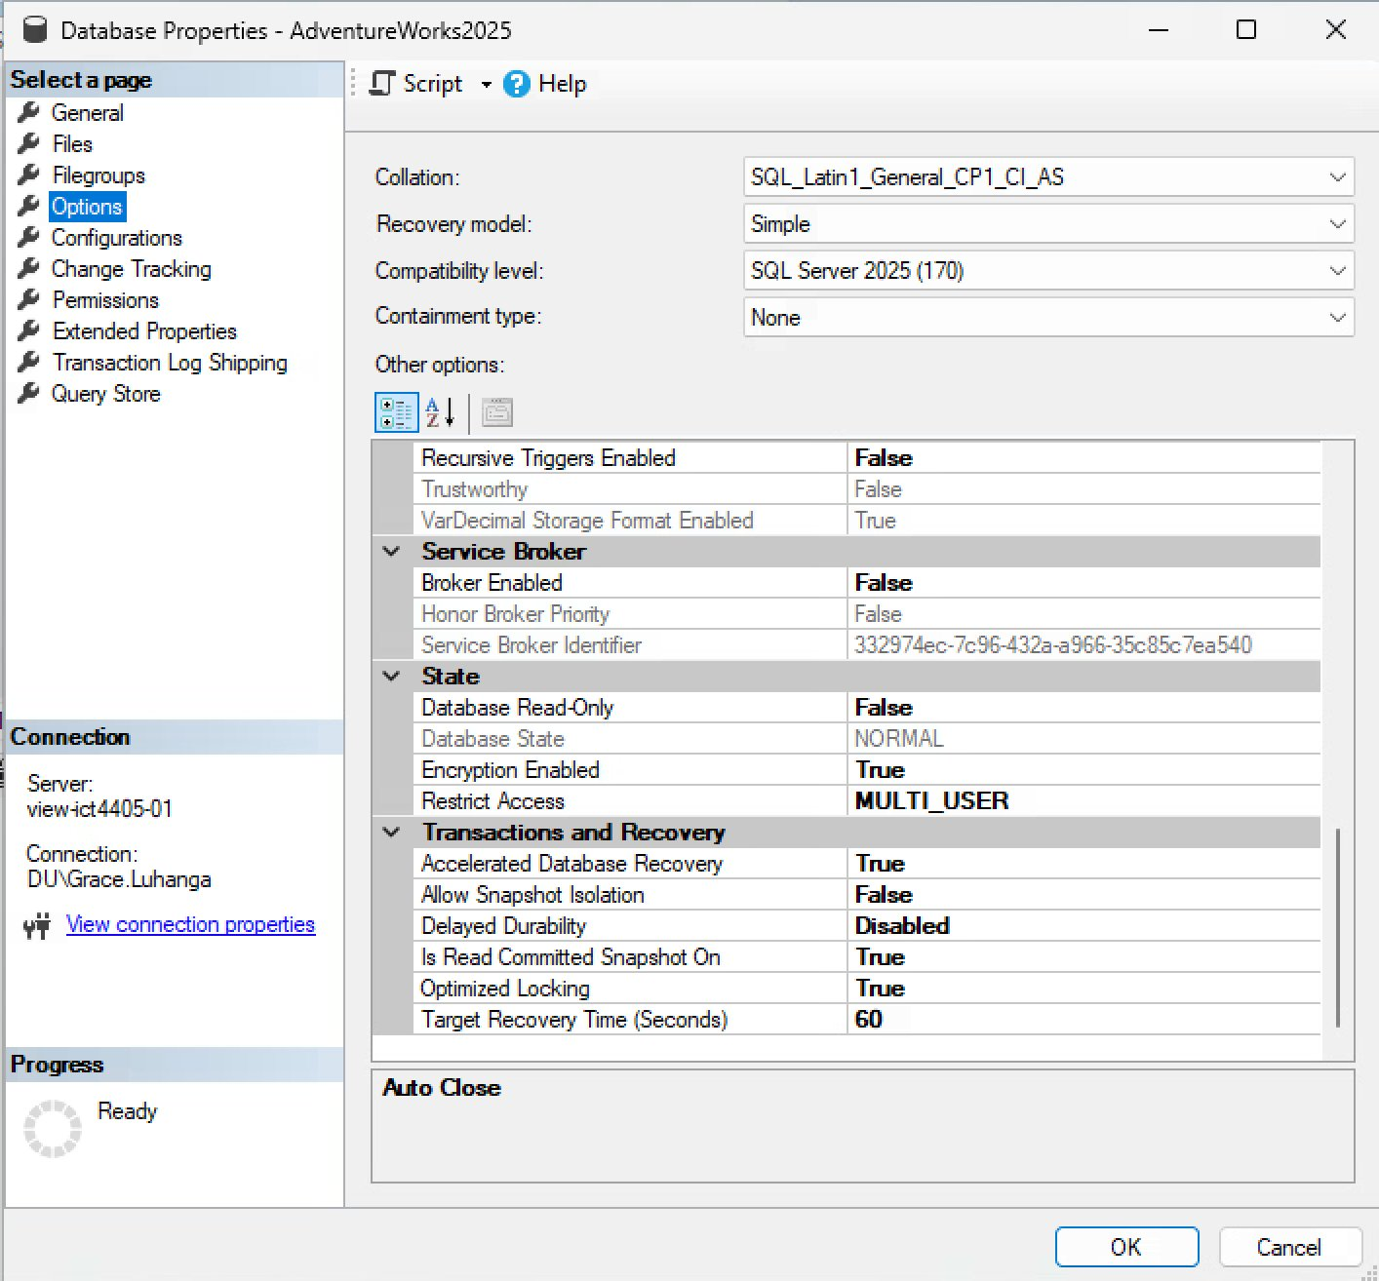

Figure 9: T-SQL verification – AdventureWorks2025 shows is_encrypted = 1, encryption_state = 3, encryption_state_desc = ENCRYPTED, AES 256-bit
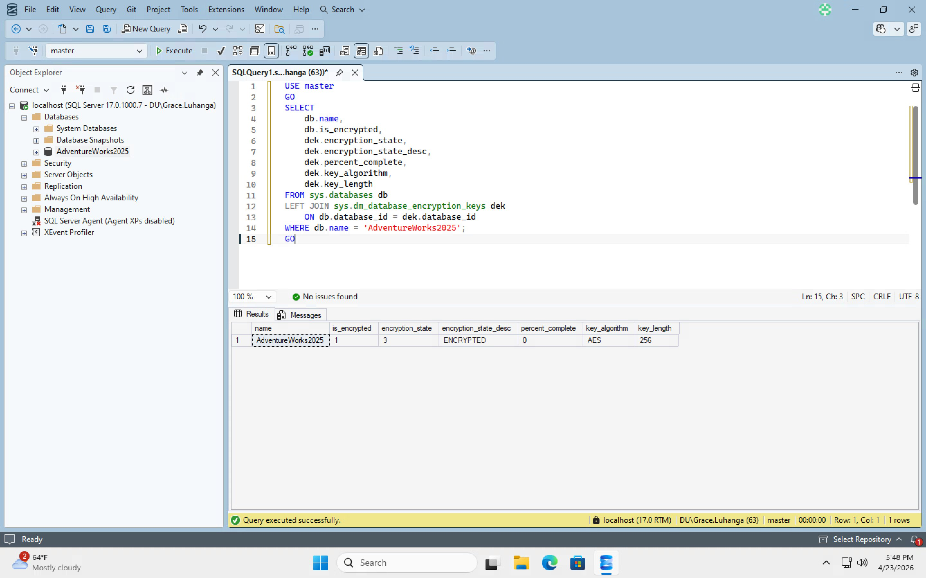

References
Bertino, E., & Sandhu, R. (2005). Database security — concepts, approaches, and challenges. IEEE Transactions on Dependable and Secure Computing, 2(1), 2–19. https://doi.org/10.1109/TDSC.2005.9
Microsoft. (2024). Transparent data encryption (TDE). https://learn.microsoft.cfom/en-us/sql/relational-databases/security/encryption/transparent-data-encryption

